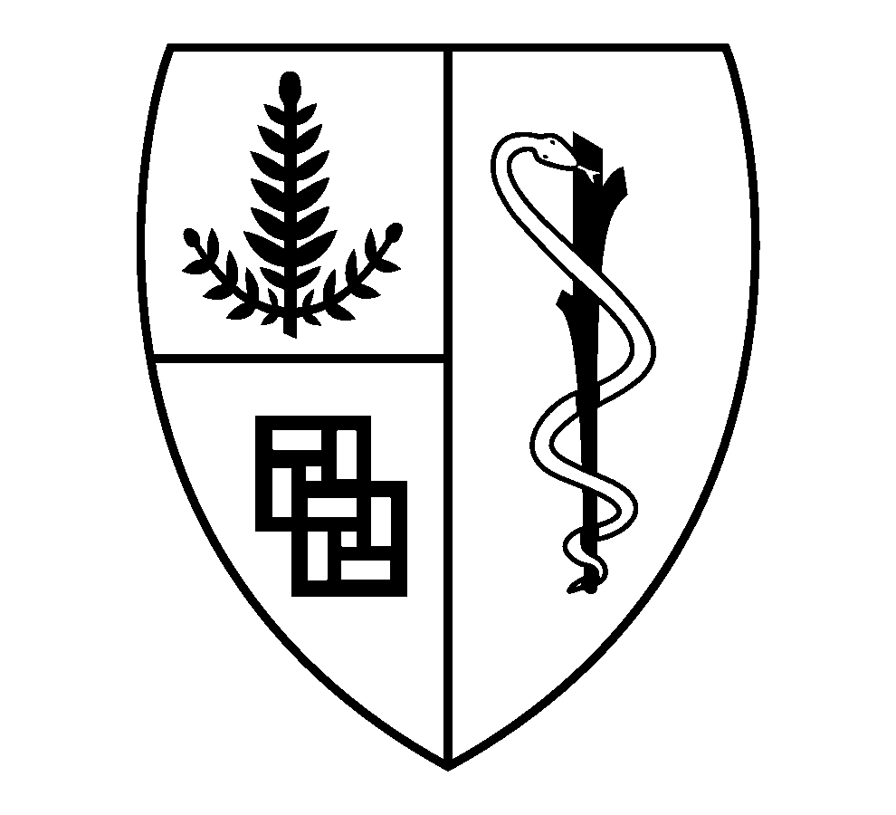

Family-Based Treatment Training Study

Stanford University
James D. Lock, MD, Ph.D.

Stanford University is conducting an NIH-sponsored study looking at how to best train therapists in delivering Family-Based Treatment for anorexia nervosa.

Who can participate?

- Therapists that have completed a masters or doctoral training in their field (psychology, psychiatry, family therapy, social work) and are licensed in their respective state

- No reports of malpractice or loss of privileges at relevant clinical institutions

- Have computer/web access for online training and assessments

- No previous 2-day in-person workshop training in FBT

- Able to submit baseline data on weight gain from week 1-4 from a previously treated adolescent with AN they have treated in the last 6 months or alternatively one that they treat within the first 3 months of completing their initial screen.

Trainings:

All participants are randomized to one of two trainings:

- Online training which consists of 10 lectures that are self-paced with a maximum of three months to complete with each lecture bundle comprising of short didactic videos that discuss the treatment model and provide mock therapy session video clips (modeling FBT with a typical adolescent AN case), as well as supplementary readings and videotaped role-plays.

- Webinar training which consists of 1-hour weekly webinar lectures over three months. There will be lectures discussing the scientific evidence supporting FBT, how therapists set up treatment for FBT, main interventions used in FBT during each phase, and recorded role-plays illustrating interventions throughout the 3 phases.

Both trainings are followed by post-online expert supervision for a minimum of 1 case and a maximum of 2 cases over the course of 3 months.

Compensation:

Participants will complete several online assessments throughout the study (Baseline, End of Training, End of Supervision) and will be paid $100 for completing each assessment. At the end of supervision, once the therapist completes a minimum of one case, the therapist will receive CE credit and a certificate of completion of FBT training as well.

How Can I Participate?

If you are interested in participating, or would like further information, contact Ayotola Onipede at (650) 723-7885; zonipede@stanford.edu

For general information regarding questions, concerns, or complaints about research, research related injury, or the rights of research participants, please call (650) 723-5244 or toll-free 1-866-680-2906, or write to the Administrative Panel on Human Subjects in Medical Research, Administrative Panels Office, Stanford University, Stanford, CA 94305-5401.

